Pi_grammer v10
SPI adapter wiring instructions
Pete Lewis
4/19/2017

For use with “linuxspi” programmer in avrdude.

Note, I originally designed the Pi_grammer to use GPIO pins to “bitbang” SPI. This is slower than using the built in SPI hardware pins on the raspi. And is problematic when programming large hex files.

The Pi_grammer hardware should be revised to use the true SPI hardware pins (and include a logic level converter to allow for 5V targets), but for now, we can wire up our adapters and only use it on 3.3V boards.

Here are the SPI hardware pins:

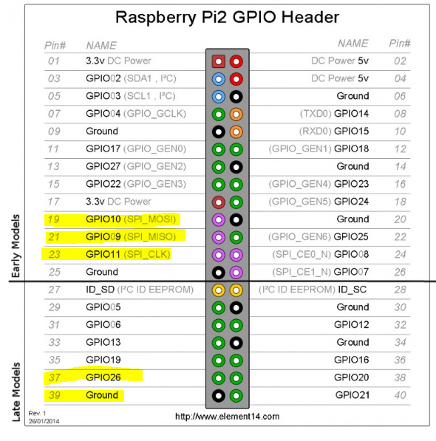

This is what it looks like on my soldered board. The MOSI/MISO/CLK actually line up nicely with the 1x6 adapter order.

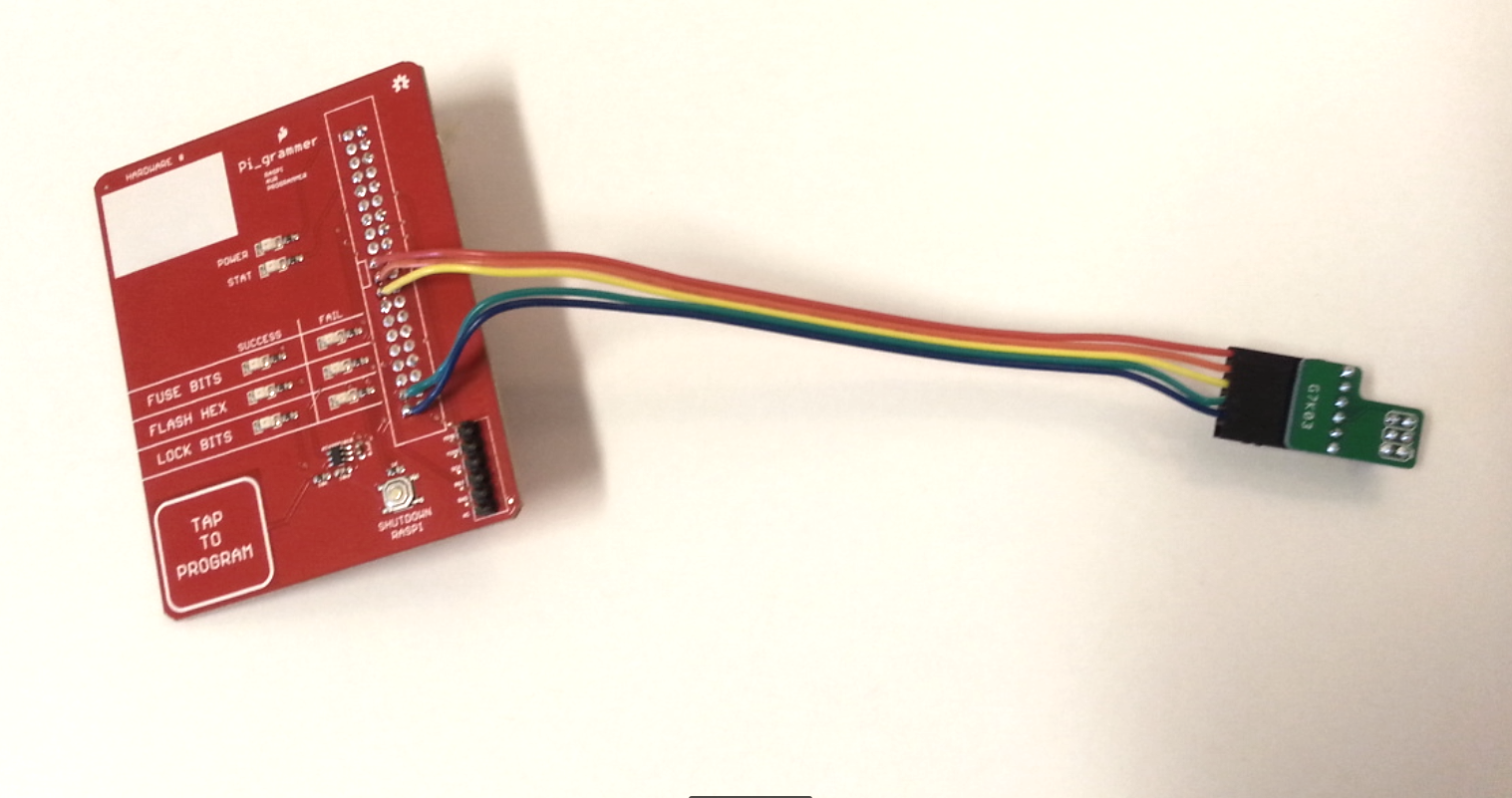
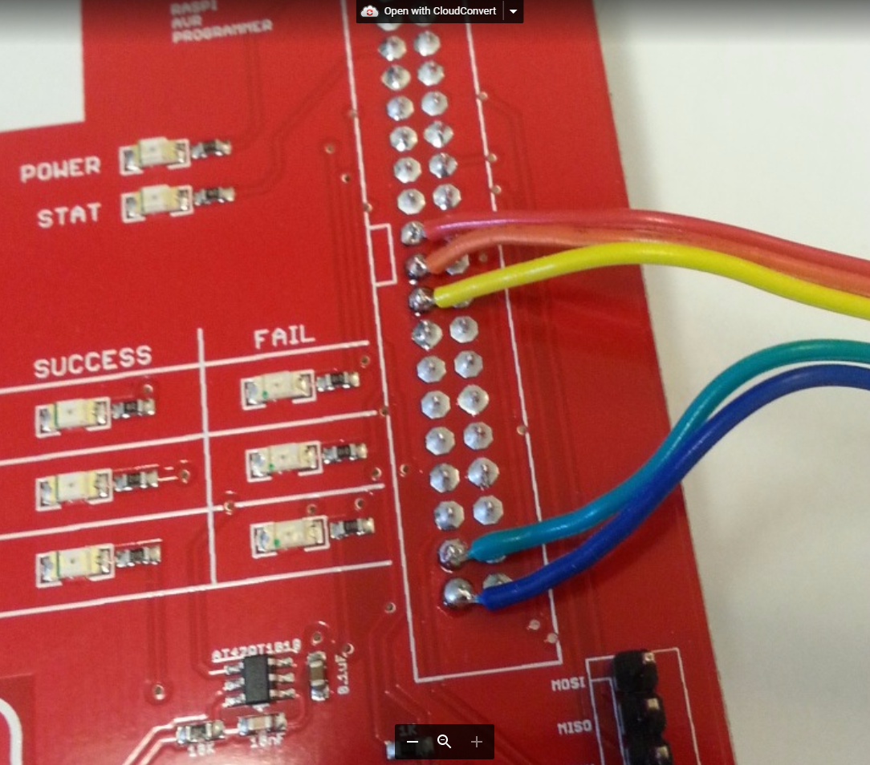 | 